|  |
| --- |
| KrazylKatz.inc |
| Assignment03 |
| **Side Scroller**  **C:\Users\Faim\Desktop\Rockman.exe\(Centennial) Semester 3.2 - (Fall - 2015)\gameCompanyLogo.fw.png** |
| Version #XX  All work Copyright © 2012 by KrazylKatz.inc  All rights reserved. |
| **Faim Hussain** |
|  |

|  |
| --- |
| October 29, 2015 |

**Table of Contents**

Table of Contents

**Type chapter title (level 1)3**

Type chapter title (level 2)2

Type chapter title (level 3)3

**Type chapter title (level 1)4**

Type chapter title (level 2)5

Type chapter title (level 3)6

**Version History**

1. **Initial commit to add default .gitIgnore and .gitAttribute files:**
2. **Mailpilot Template:**
   1. Using class demo for “MailPilot” as a template.
3. **Commit 3 - Added assets, json files, and start scene**
4. **Commit 4 - Added background scrolling and scoring**
5. **Commit 5 - Added the player**
6. **Commit 6 - Added enemies, pickup, scoring, and sound effects**
7. **Game Overview**

Basic 2D scrolling game where spaceship flies in an unknown galaxy to find precious jewels of the space gods while avoiding enemy spaceships that want to protect the so called jewels.

1. **Game Play Mechanics**

Mouse controlled spaceship collecting pickups and avoiding enemy objects. Player starts with 3 lives and the initial score of ‘0’.

1. **Controls**

The spaceship follows the mouse’s y position, the player moves up and down on the vehicle’s pre-set x-axis value.

1. **Interface Sketch**
2. **Screen Descriptions**Instructions Screen:

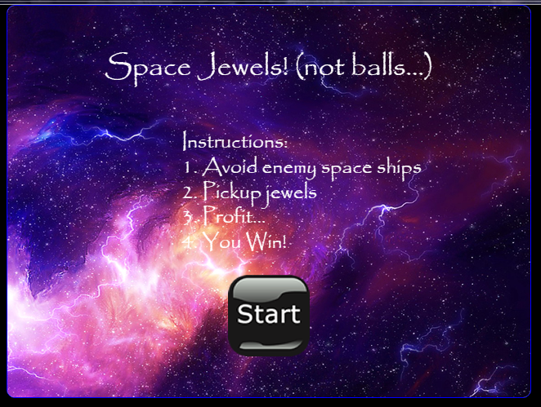

Gameplay Screen:

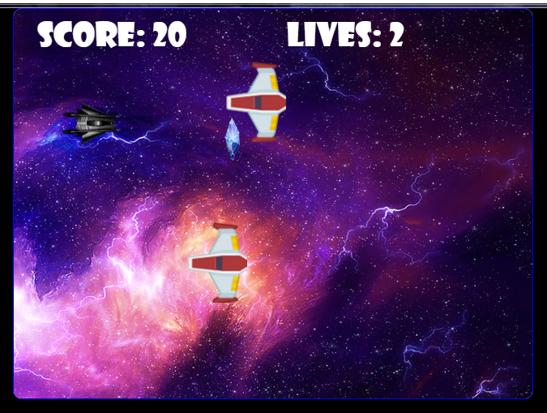

Gameover Screen:

1. **Characters/Vehicles**

Luck the Ski runner pilots his late uncle Ken Benobi’s starshooter across the galaxy to find the mysterious jewels.

1. **Enemies**Enemy spaceships protect the jewels, and are committed to sacrifice themselves to recollect them before the player has a chance to steal them. They attack by diving to the player and self desctructing.
2. **Scoring**The player receives points by gaining jewels that are randomly placed on the screen.
3. **Sound Index**

{ id: "backgroundMusic", src: "../../Assets/audio/backgroundMusic.mp3" },  
{ id: "explode", src: "../../Assets/audio/explode.wav" },  
{ id: "pickup", src: "../../Assets/audio/pickup.wav" }

1. **Art / Multimedia Index**

* Player’s space ship:



* Enemy space ship:



* Pickup item



* Scrolling background:



* Start button:

